

**Mohamed Abshan**

1823486

**A Gesture Based Interactive Website for Children to Learn**

BSc (Hons) Computer Science and Software

Engineering

Undergraduate Thesis Report

University of Bedfordshire

Dr. Yasas Jayaweera

### Academic Year Here

**Abstract**

In the current world, there are many ways of learning options available and these methods of learning are used by tutors to teach their students and for individuals who learn by themselves using these as their guide. Learning via the internet is somewhat the most popular learning method being used in the past decade. Learning can be accomplished in many ways, but the concern related when it comes to learning is how to make learning more interesting. Science has proven that interactive learning is the best solution for making learning more interesting. Currently there are several interactive methods of learning methods available online but still, these methods lack somewhat interaction with the person, who is using these methods to learn. This is a huge concern when it comes to children, who are using e-learning websites for learning purposes. To tackle this problem with children being less engaged while using learning websites, this project is aimed at resolving that issue by introducing a new way of interactive learning for children to keep them engaged while learning.

**Keywords**

Web browser; Web application; Machine Learning; Deep Learning; Artificial Intelligence; E-learning.

**Acknowledgement**

**Content Page**

**List of Figures**

**List of Tables**

**Acronyms**

1. **Introduction**

This section of the report, topics such as project background, project objectives, project outcomes and the structure of the final thesis report will be discussed further.

* 1. **Project Background**

The number of learning methods available for teaching and learning purposes presently is growing gradually. Some of these learning methods has become globally available and improved with the help of technology, where as in learning using technology has become a crucial part of the learning process and, an intuitive way of learning these days. The learning methods that are associated with technology is being used in the educational field in different ways, which helps both the tutors and the students to carry on with their lessons. The possibility of sharing and accessing lessons and study materials via internet has enabled tutors to share lessons and study materials for students to access from anywhere in the world. This allows the students to learn what they want, when they want and how they want as a result of accessibility to online resources. The online resources available for learning purposes is growing exponentially as well as the number of people using them. To make it more convenient for the user to find and use these resources, there are several websites available on the internet that allows to share these resources for learning purposes, and this sort of websites are generally called as ‘e-learning’ websites.

The purpose of e-learning websites is to provide lessons and study materials on various subjects for students in different grades and fields. These e-learning websites take different approaches on providing lessons to the user in different styles according to their age. When it comes to learning, having children engaged in these lessons is a difficult task and it’s more difficult when it involves children who wants to self-learn. For children who seeks learning websites to educate themselves, these e-learning websites try various methods to keep them engaged with their lessons by making lessons more interactive and fun. Making e-learning websites to look more attractive and adding the element of joy to the lessons by conducting them via games and videos are some of the approaches they have taken to keep children engaged in the lessons. This allows children to educate themselves in an exciting manner. The level of involvement and interactivity when learning online compared to learning in school classroom is low in many ways, where as in, lessons that are made for children in their elementary school or middle school are prepared in a way that each lesson is conducted in a way to keep them engaged while learning. This level of involvement can be achieved in e-learning websites if there’s a way to conduct same kind of activities in the website. For example, a question and answer session in the classroom, which can help to conclude a lesson topic as well as to recall what they have learned previously. This way children can improve their studies and knowledge by answering practice questions related to various subjects in an interesting way which will keep them involved. Introducing an interactive learning activity as such into e-learning websites can help children to learn in an interesting manner.

Creating a website is the best choice to achieve a learning method like this because of its accessibility and availability. Children will be able to access the website and answer questions related to different subjects under different grades by interacting with the website in an exciting way which will keep them focused and joyed throughout the time they spend on this website. Allowing children to answer and control the questionnaire using hand gestures would help in keeping them engaged while using the website. These hand gestures are captured via the web camera of the computer or the laptop and processed using machine learning to detect specific gestures to effectively execute tasks like answering and controlling the questions without any external inputs like a keyboard or a mouse. Introducing a new way of interaction into e-learning which is similar to a classroom true or false question and answer session, where the tutor asks the question and the student raise their right and left hand accordingly to answer if the statement is true or false. In this website, true and false questions are used to get the user to answer the questions using gestures. The reason for choosing true and false questions is that it only consists of a question and two answer options, and this type of questions are well suited for this website, also it serves the purpose of the website (ClassMarker Online Quiz Maker, 2019).

* 1. **Project Aims and Objectives**
     1. **Project Aims**

This project aims to improve the learning conditions related to school course outline, which would help children regarding their school curriculum by letting them sharpen their knowledge through answering questions from different subjects in an actively engaging manner.

* + 1. **Project Objectives**
* Create a website for children to answer questions related to their school curriculum by interacting with the website using gestures.
* Evaluate different methods of which machine learning can be used in the field of web development.
* Evaluate machine learning technologies available in websites.
* Design an algorithm to capture hand gestures.
  1. **Description of Artefact**
  2. **Structure of Report**

The final thesis report consists of different chapters which are made in a sequential order to give a clear understanding to the reader on what’s been discussed in the report. This report consists of seven chapters which will consists of,

1. Introduction
2. Market Research
3. Literature Review
4. Methodology
5. Results and Discussion
6. Evaluation
7. Conclusion
8. Future Work

In the introduction chapter of the report, will be discussing the project background, project aims, project objectives, to describe what the project is about as well as what are the aims and objectives of this project. In addition to that, introduction chapter will include a description about the artefact along with the development of the artefact as well. In the market research chapter of the report, current market of e-learning will be discussed based on a survey results. In the literature review chapter, will be about the research topics related to the project, by referring to journal articles and research articles plus other online articles. In the methodology chapter, will be discussing the project in each phase using supporting diagrams and tables, starting from the process of planning, requirement gathering and analysis plus design and implementation. In the results and discussion section of the report, will be discussing the outcomes of the project and each functionality of the completed product by providing relevant images and parts of codes. In the evaluation and testing section, will discuss about how the evaluations was done on the product and the testing’s done on by providing all the test cases that the website underwent. In the conclusion part of the report, will conclude an overall summery of this report and in addition to that it will discuss about the benefits of using this product and whether the product has met its goals and objectives. Finally, in the future work section of the report, will be discussing about the future work that could be done to completed product.

1. **Market Research**
   1. **Research Purpose**

In order to introduce a new way of learning in to the field of e-learning, it’s better to make sure whether a learning method of this kind is needed and would be able to stand a chance among the other learning methods available at the moment in the e-learning field. Therefore, by doing this market research should be able to find out,

* Average use of e-learning websites
* State of current e-learning websites
* Average age of e-learning users.
* Chances of improvement in e-learning

* 1. **Research Method**

With the purpose of performing a market research, a quantitative research was conducted. Quantitative methods are very convenient when it involves numerical data (Theclassroom.com, 2019). Since, most of the expected results of this market research is based on numerical data, the research method used for this market research was a simple survey. The output of the final data from the survey was analyzed by the researcher to understand the current standing of e-learning and the market feasibility of the proposed learning method.

* 1. **Research Survey**

For the purpose of understanding the current standing of e-learning in the society and the market feasibility, the researcher used a quantitative research approach to collect numerical data by making a survey questionnaire regarding e-learning. The conduction of the survey involves a questionnaire that was made using Google Forms (Docs.google.com, 2019), where it was used to collect numerical data concerning the usage of e-learning and the current state of e-learning. The most important advantages of using quantitative survey research method was that, data collection is very convenient and the ability to reach many participants in a short period of time in a cost-effective way is very helpful. However, there is a risk of getting invalid responses from the participants due to the lack of encouragement and knowledge on the subject to respond with accurate and honest answers, and this could affect the surveys reliability (Explorable.com, 2019).

As for the structure of the questionnaire, researcher designed it to be simple for the reason that the main targeted participants for the questionnaire being students from junior grades and junior high school grades. Some particular questions were designed, so the numerical data collected using the survey fulfills the purpose of it.

Some of the sample questions that were included in the survey form were the followings.

(A detailed form of the survey form is presented in Appendix B)

**Question 1**: What is your age? (Multiple Choice ‘Under 12’, ’12-17’, ’18-24’, ’25 and above’)

**Question 2**: Have you ever used an e-learning website for learning purposes? (Multiple Choice ‘Yes’, ‘No’)

**Question 3**: Reasons for not using e-learning? (Checkboxes ‘Never heard of e-learning’, ‘Not affordable’, ‘Don’t like the teaching method’)

**Question 4**: How often you would use e-learning websites to learn? (Multiple Choice ‘Occasionally’, ‘Sometimes’, ‘Often’, ‘Always’)

**Question 5**: Which learning method do you think suits the best for you? (Multiple Choice ‘Traditional Learning Method’, ‘E-Learning Method’)

**Question 6**: How would you rate the interactivity of these e-learning websites with the user? (Linear Scale ‘1 to 5’)

**Question 7**: Select the methods of learning you have used in e-learning websites? (Checkboxes ‘Video Tutorials’, ‘Questionnaires’, ‘Question Papers’, ‘Practical’s’, ‘Games’, ‘Documentaries’)

**Question 8**: Do you think e-learning methods can be improved further? (Multiple Choice ‘Yes’, ‘No’, ‘Maybe’)

* + 1. **Survey Data Analysis**

The responses that were obtained through the survey was analyzed by the researcher to get an idea of the e-learning usage among students. Which was very helpful in ensuring the market feasibility of the project and being aware of the target audience of the proposed system.

Q1. **What is your age?**

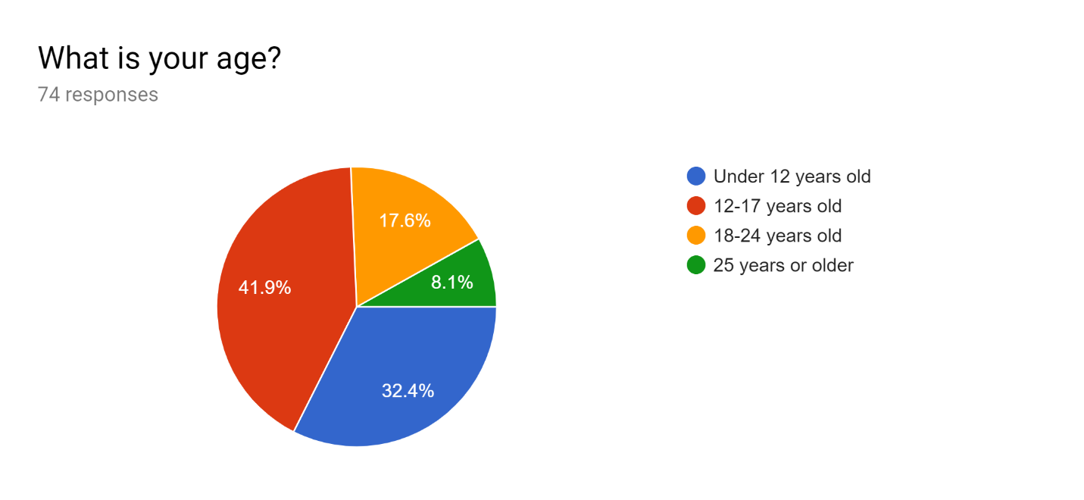

Figure 1 Market Research Survey Question 1

The main target audience that was selected for the survey were students from lower grades, where as in, majority of the respondents 31 out of 74 (41.9%), were in the age group of 12 to 17 years old. Secondly, 24 out of 74 students (32.4%) were in the age group below 12 years old making it the second highest group of respondents. Finally, 13 out of 74 (17.6%) and 6 out of 74 (8.1%) of the respondents were from the age groups of 18 to 24 and above 25 accordingly.

Q2. **Have you ever used an e-learning website for learning purposes?**

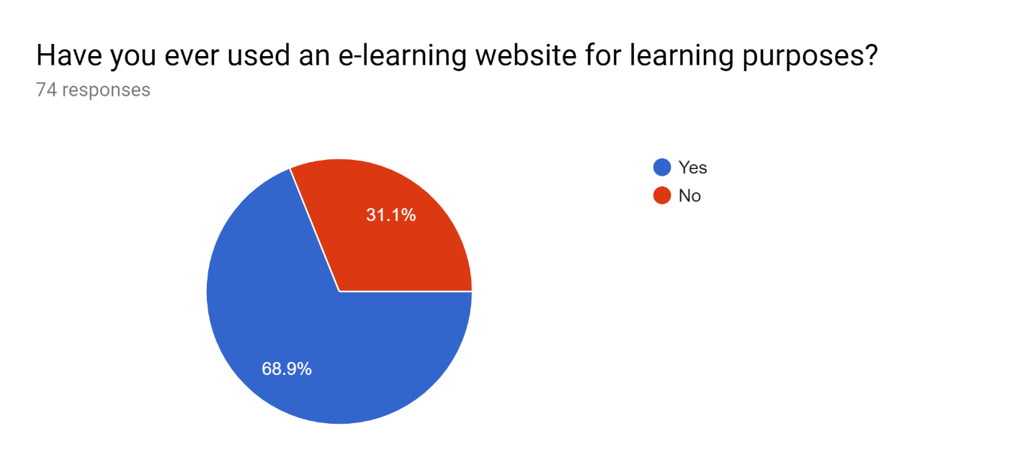

Figure 2 Market Research Survey Question 2

Out of 74 respondents who took the survey 51 students (68.9%) have used e-learning websites for learning purposes and 23 out of 74 (31.1%) students have responded that they have never used e-learning websites.

Q3. **Reasons for not using e-learning?**

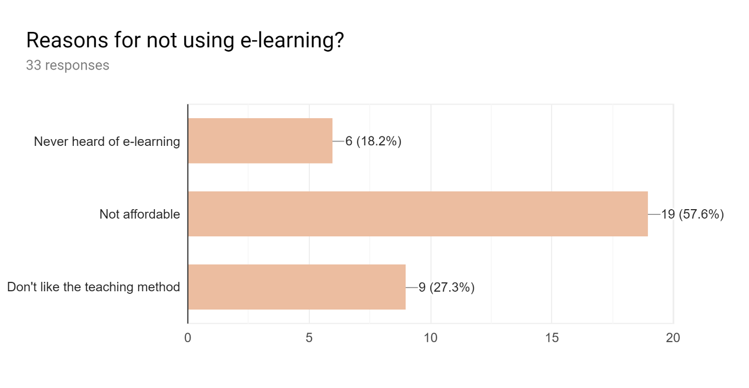

Figure 3 Market Research Survey Question 3

For this question, only 33 has responded and out of the 3 options presented in the question, 19 out of 33 respondents think that e-learning is not affordable and 9 out of 33 respondents don’t like the teaching methods that e-learning websites use. And 6 out of 33 respondents have never heard of the term e-learning.

Q4. **How often you would use e-learning websites to learn?**

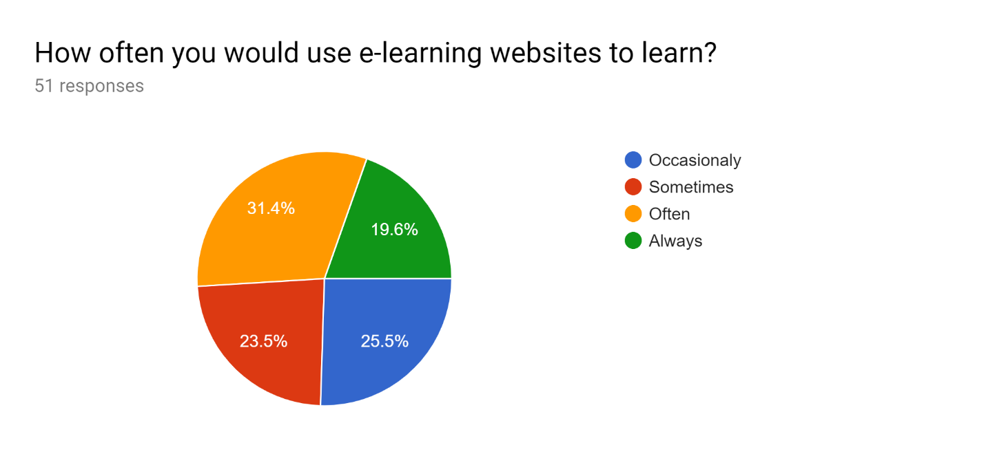

Figure 4 Market Research Survey Question 4

From the 51 respondents who has used e-learning websites, 16 out of 51 (31.4%) respondents use e-learning websites more often to learn and 13 out of 51 (25.5%) respondents use e-learning websites occasionally. Only 12 out of 51 (23.5%) respondents use e-learning websites less often, where the remaining 10 out of 51 (19.6) respondents use e-learning websites very often.

Q5. **Which learning method do you think suits the best for you?**

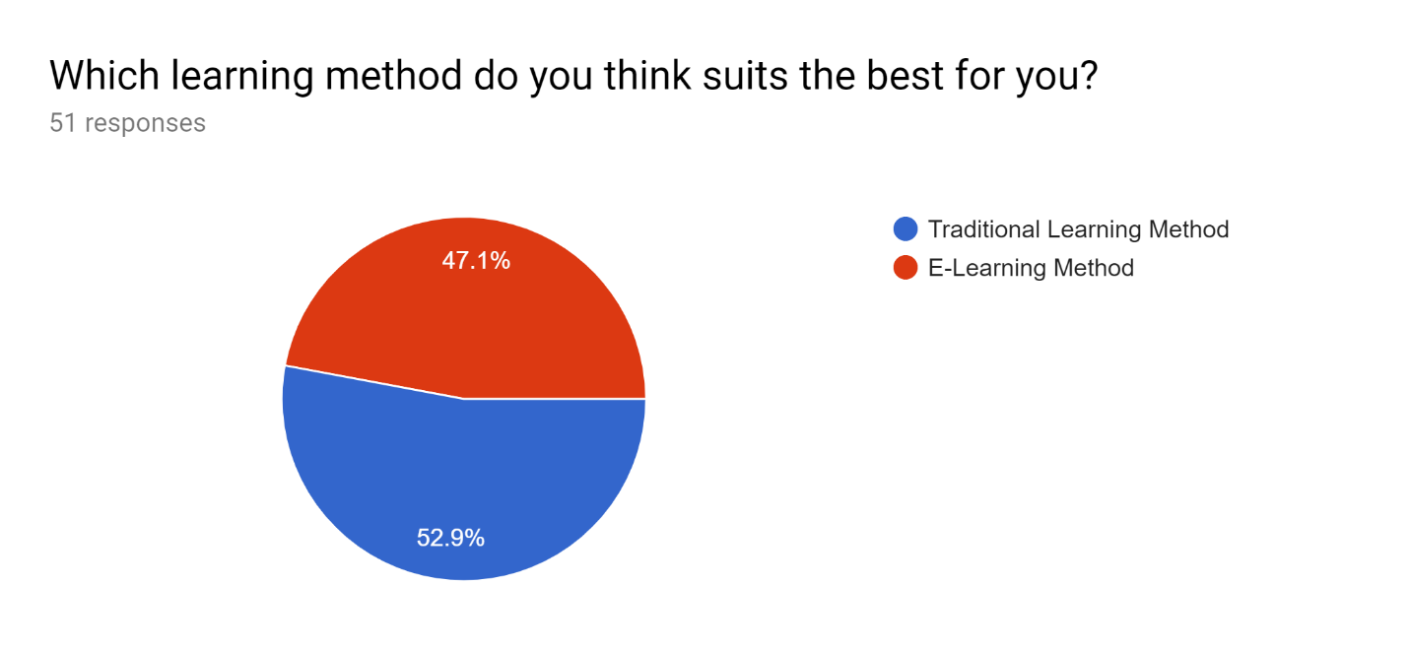

Figure 5 Market Research Survey Question 5

Respondents were asked to select the best suited learning method for them and, 27 out of 51 (52.9%) preferred traditional learning method and the remaining 24 out 51 (47.1%) chose e-learning as their preferred learning method.

Q6. **How would you rate the interactivity of these e-learning websites with the user?**

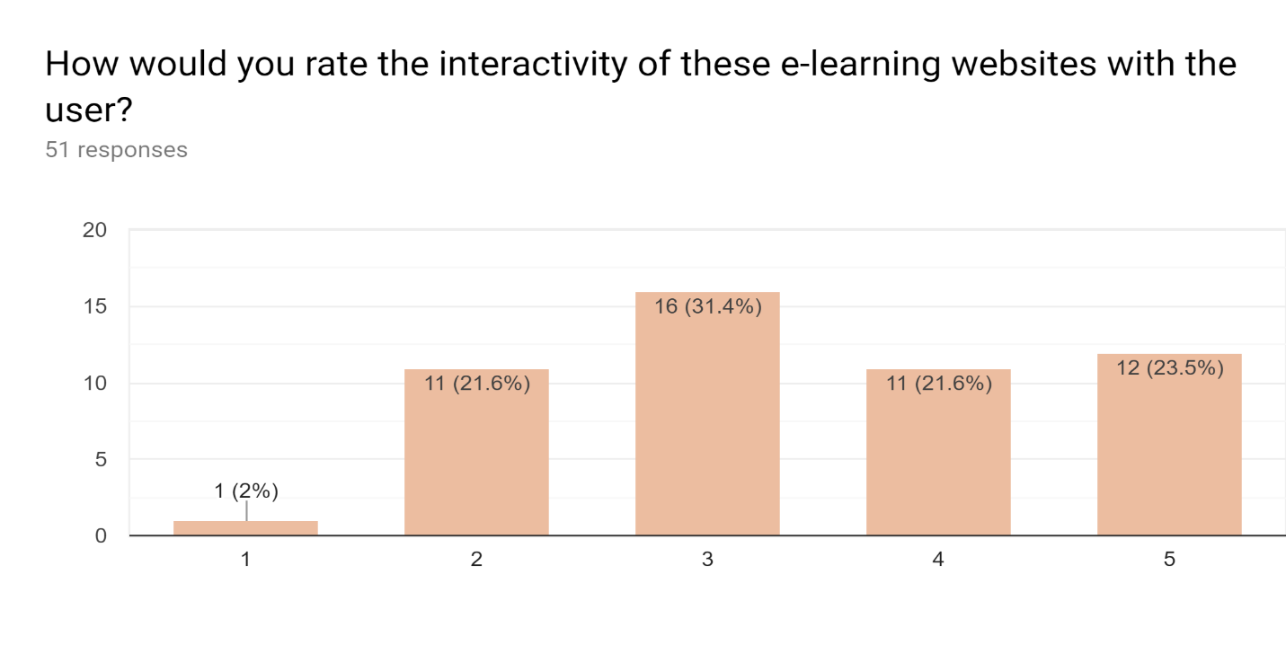

Figure 6 Market Research Survey Question 6

When the respondents were asked to rate the level of interactivity in the e-learning websites they used, 16 out of 51 respondents gave a rating of 3 which is satisfactory and only 1 responded with a rating of 1 which is very poor. There were 12 out of 51 respondents who gave an outstanding rating of 5 and both the ratings of 2 and 4 got rated equally from the respondents which is 11 out of 51 for unsatisfactory and 11 out 51 for very satisfactory respectively.

Q7. **Select the methods of learning you have used in e-learning websites?**

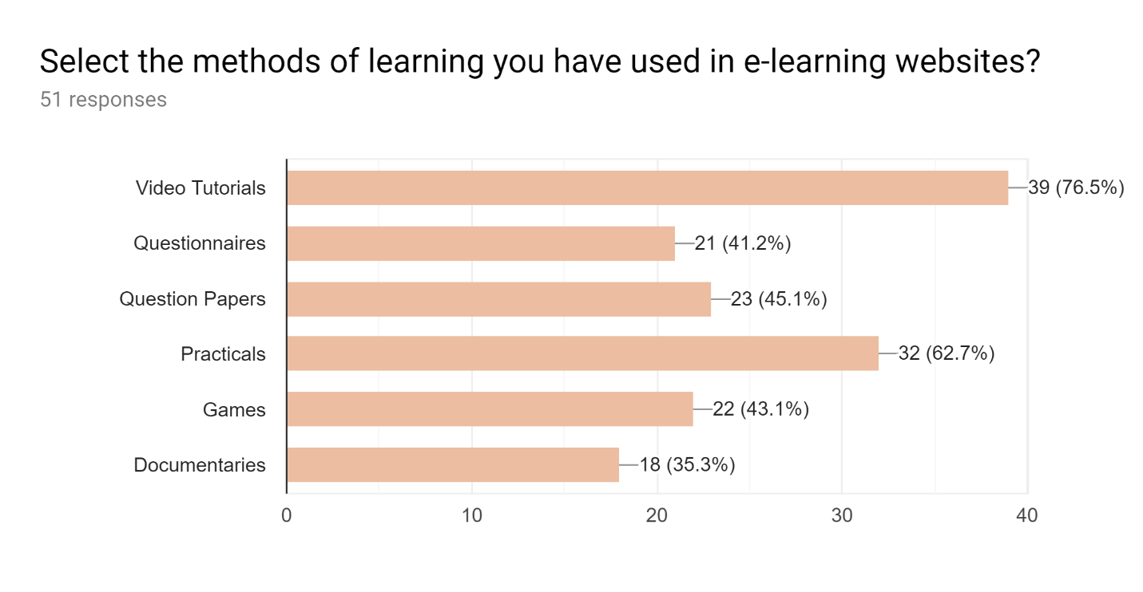

Figure 7 Market Research Survey Question 7

This question was asked from the respondents in order to recognize the most used learning methods available in the e-learning websites. 39 out 51 has selected video tutorials and 32 out of 51 has selected practicals as their e-learning methods, where almost everyone who is in the age groups of 18 to 24 and 25 years old and above has chosen video tutorials and practicals as their methods of e-learning and only a few from the age group of 12 to 17 years old have chosen those two methods. Nearly everyone from the age group between 12 to 17 years old has chosen question papers and documentaries as their method of learning which is, 23 out of 51 responses and 18 out of 51 responses respectively and only a very few has chosen questionnaires as well. The respondents who were below the age group of 12 has selected questionnaires and games as their method of e-learning which is 22 out of 51 and 21 out of 51 accordingly.

Q8. **Do you think e-learning methods can be improved further?**

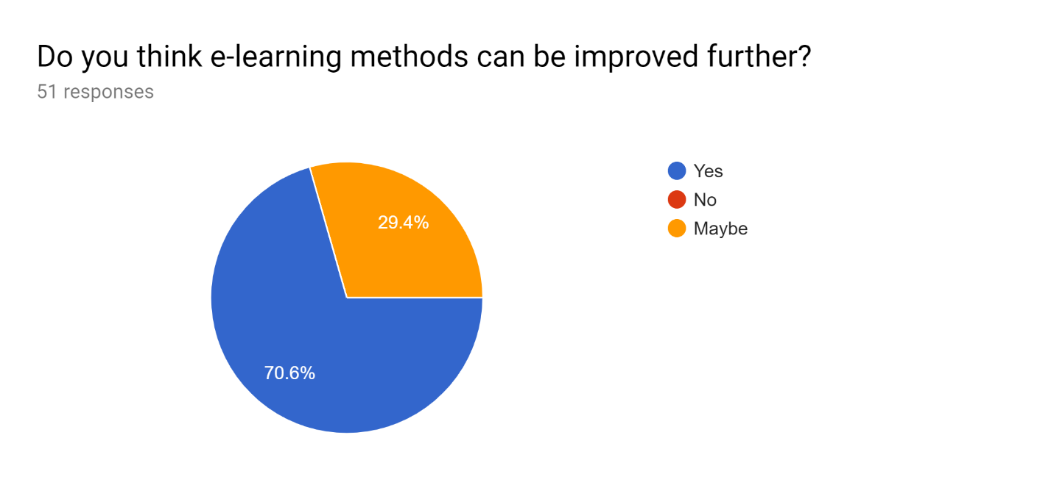

Figure 8 Market Research Survey Question 8

One thing that all the respondents agreed on fully or partially was the fact that there is still room for improvement in the methods of e-learning. 36 out of 51 (70.6%) respondents agree that e-learning methods can improve further and 15 out of 51 (29.4%) were not sure about whether there are any possibilities of improving e-learning methods.

* + 1. **Survey Summery**

From analyzing the results of the survey it was found that most of the students depends on e-learning websites, where some prefer e-learning methods more than the traditional learning methods because of the learning possibilities and the interactive methods available in these sites. Researcher was able to find out the average use of e-learning among students and the e-learning methods that students from different age groups use, which helped a lot in narrowing down the requirements needed and figuring out the target audience for the proposed learning method.

1. **Literature Review**

In this chapter of the report, will be doing a literature review on the research topic gesture based website for children to learn by discussing the current standing of e-learning and other approaches that e-learning websites have taken. Thereafter will be discussing technologies that can be used in improving the interaction between user and the website for achieving a level of interactivity concerning current examples on how the technology current technology have been used to address this problem in the web development field.

* 1. **E-Learning Background**

The method of online learning called ‘e-learning’ was emerged with the help of technology and its being used by many in the world currently. Technology has made it easy to access these e-learning websites through many devices that we use in our day to day life, such as computers, laptops, smartphones, tablet computers, and even smart televisions. The current generation is highly dependent on technology and the familiarity they have with this technology has allowed them to discover new possibilities that comes with it. This relationship that users have with the technology has caused an increase in the number of users using e-learning as their secondary learning method where as in some cases e-learning is used as their primary learning method, which makes e-learning as one of the important learning environment at present. There is a problem with e-learning which is a common problem that exists in other learning methods as well, where the learning method used in e-learning should be well-suited for human capabilities when it comes to learning. E-learning can be used in two ways, asynchronous (self-learn) and synchronous (classrooms). At present, more than 60% of the students use e-learning websites to self-educate themselves. One of the reasons why students prefer using e-learning to educate themselves is that they get to control the pacing of learning. The current e-learning sites available in the internet takes different measures to provide a good cognitive learning experience to the user. This involves attractive and engaging methods of learning that uses different presentation styles and graphics to deliver a unique experience to the user. Individuals who use this websites might or might not like what they see or how the learning content is arranged and presented at them. These sorts of drawbacks not only affects in keeping the user engaged but also in content deliverance and growth of the website. To prevent e-learning websites from falling into such state, they try different approaches to achieve the goal that is appropriate for learning and increase the effectiveness by adding the element of joy into e-learning websites such as games, videos, and social media to bring the interactive experience into these websites. Delivering animated learning content with such interactive methods have attracted people of all ages to access these sites and use them for learning purposes (Reuters.com, 2019). E-learning is being used in the standard education environments like schools and institutes to deliver instructions and learning materials to students. With the increase in number of internet users traditional teaching ways that were used in education environments are being replaced by e-learning methods to increase the productivity of teaching and lessen the cost of education, where as in no one is stuck anymore with the traditional learning methods and models and it clearly shows that e-learning is undoubtedly the future (Ferriman, 2019).

* + 1. **E-Learning Websites**

At the moment there are many e-learning websites available for children to learn. These websites offer lessons and courses on different fields and grades. Some of the e-learning websites available in the internet offers free lessons and course materials to the recipients and the rest of the websites deliver education for a price with rich learning materials. K12 (K12, 2019), is an e-learning website that provides learning possibilities for children who wants to home school online. Students have the option to choose between public and private lessons which are conducted by independent teachers and teacher-led lessons found in the USA, which includes lessons from kindergarten to 12th grade. Students get to choose the learning phase and time of the day to learn, which makes it more convenient for them. Khanacademy.com (Khan Academy, 2019), is a popular e-learning website available in the internet which offers free and interactive lessons for a large variety of subjects. Students can choose whether to follow an entire subject or just get to a challenging quiz or a tricky part of a subject, through watching a video related to that specific lesson. Free service and access to rich learning resources is a key factor of its popularity, where as in many e-learning websites lack in that matter. Brainpop.com (Brainpop.com, 2019), is a complete subscription based e-learning website for children which offers both homeschooling and traditional schooling lessons for a yearly price. This website offers quizzes, animated movies, and educational games under different subjects to get the children engaged with the lessons. Udemy (Anon, 2019), Coursera (Coursera, 2019) and Lynda.com (Lynda.com – from LinkedIn, 2019), are some of the leading flexible and effective e-learning platforms available in the internet which offers access to many courses ranging from, programming, photography, animation, designing and many, many more for an affordable monthly subscription price. These three websites provides an open platform for the tutors and industry experts to create their own courses by providing study materials such as videos and practical files to work with (Medium, 2019). Most of the e-learning websites discussed above take user interaction up to a standard, wherein some websites lack the necessary interaction with the users to have them engaged and drawn towards the website, which leaves them with no intention of visiting these websites except for desperate situations (Learning Liftoff, 2019).

* 1. **Machine Learning Background**

Machine learning is an involvement of algorithms which is a subpart of Artificial Intelligence. This technology allows computers to learn without any super complex programming to come up with calculated predictions on its own, using sample data. Machine learning is being used in many ways on different platforms to execute and optimize different tasks. It is one of the trending topics among the other topics in the computer science world. Machine learning can be divided into two main aspects, supervised and unsupervised. In a supervised machine learning system, a model has to be trained to get the task done by providing a set of inputs and relative outputs so that the system will be able to learn the association among the two and calculate a prediction. As for the unsupervised machine learning systems, only the input data set is provided and it's not labeled. It uses cluster analysis to detect the commonalities that are present or absent on each data provided to differentiate them accordingly (Alpaydın, n.d.).

Deep learning is a class of machine learning algorithms based on neural networks. This method allows the computers to learn by experience and understand the hierarchy of concepts with each concept relative to a simpler concept. Deep learning uses flowing nonlinear processing units called neurons to transform and feature extraction. Each layer of neurons uses the output of the previous layer as the input. Deep learning consists of two main phases, the training phase, and the inference phase. In the training phase, it uses the inputs to compute the parameter of the model and once the model is trained in the training phase, the inference phase uses the trained model outputs to determine the sample input. The training phase needs a lot of computing power in case to train the model and the inference phase can run on any device where it only compares the inputs with the trained model (Goodfellow, Bengio and Courville, 2016).

* + 1. **Machine Learning on Web Browser**

As mentioned earlier machine learning can be used on any platform nowadays with the correct tools and knowledge. Within the past three decades, people started embedding machine learning into web applications as well. Popular web applications used machine learning on their web applications mainly to enhance the user experience and for other different use cases, for example (Forbes.com, 2019),

* Search engines (Google search engine)
* Spam filters (Gmail spam filter)
* Recommendation systems (YouTube recommending system)
* Pattern discovery in internet data (Big Data)

With the growing popularity of artificial intelligence, many machine learning and deep learning embedded applications are currently available, e.g., image processing, object tracking, speech recognition, and natural language processing. On the rise of applications adopting artificial intelligence into their systems, new tools were needed. Therefore such frameworks and libraries were introduced and being used currently. When it comes to machine learning applications, data is being collected in different ways to run these machine learning algorithms. This was a big concern regarding user privacy and time. Therefore application developers started designing applications in a manner where these machine learning tasks can run on the client side. Web browsers also wanted to adapt to this client-side computation method, where several in-browser machine learning applications were implemented. Machine learning in the browser is mainly implemented using JavaScript and executed on the browser engine (Ma et al., 2019).

* + 1. **Selected Frameworks**

TensorFlow.js (TensorFlow, 2019), is launched by Google in March 2018 and released as an open source library. Previously it was known as deeplearn.js which was called TensorFlow.js later. It is a JavaScript library that can carry out tensor operations in the web browser engine. It allows us to define parameters, train models and run models entirely on the browser engine using JavaScript. TensorFlow.js supports all the Keras layers (Keras.io, 2019) and it allows the developer to import and run native pre-trained models using TensorFlow and Keras in the browser with TensorFlow.js (Smilkov et al., 2019).

Ml5.js (Ml5js.org, 2019), is a library that’s been built on TensorFlow.js to provide access to machine learning algorithms on the web browser. ML5.js is an open source library that act as an interface to TensorFlow.js which could be used by anyone to run machine learning algorithms that can handle GPU accelerated operations and memory management on the browser. ML5.js library provides some pre-trained models to be accessed on the browser to run machine learning algorithms in real time (Medium, 2019).

* + 1. **Production Application**

JavaScript has become a popular and powerful programing language, where it’s being used in many platforms including web applications and desktop applications. Recently TensorFlow.js has become a trending topic within the JavaScript community. The in-browser implementation of TensorFlow capabilities has made it easy to use on the web and beyond. TensorFlow.js extends its machine learning possibilities to the JavaScript developers to explore new domains and enhance user experiences in new ways. Allowing to run models directly on the browser helps the developers in portability, development and the ability of easy interaction with web interfaces. There is no need of sending data to server when running models because it’s running on the client’s browser which gives the ability to the developer to do quick fixes, train models and tweak models are some of challenges that are being faced by the developers when it comes to machine learning. These are some of the reasons why developers prefer running machine learning of the client side and using TensorFlow.js as the framework to develop applications that have machine learning requirements (TensorFlow, 2019).

* + 1. **Gestural Interfaces**

Gestural inputs captured via webcam in real time can be achieved via TensorFlow.js. This has shown many promising results that use gestural inputs to execute events. Developers who use TensorFlow.js have built applications that allow users to interact with the web conveniently and in new ways. Complex AI- driven tasks that used machine learning, needed high computing and processing power to run the applications, wherein TensorFlow.js has made those complex AI-driven tasks to look like trivial tasks with its power.

Abhishek Singh (Singh, 2019), has built a web application that translates sign language to speech-language that allows the user to communicate with an Amazon Echo. A machine learning model was trained to detect different sign languages so that the browser can convert the input query into a text-to-speech format so that the Amazon Echo device can understand, which is done using TensorFlow.js.

Ramos (Ramos, 2019), has introduced a way to improve the accessibility of the web pages by allowing users to interact with the web page without any keyboard or mouse inputs. Ramos has developed a library called handsfree.js using TensorFlow.js so that this hands-free input method can be implemented on other applications. Ramos uses head-tracking to control the web pages, by allowing the users with the limited motor skills to control the web browser with their face movement. Ramos's head-tracking library can be used on any interface of a service, website, and devices of the Internet of Things.

Jane Friedhoff and Irene Alvarado (Friedhoff and Alvarado, 2019), has made a web application called Move Mirror, which matches the poses made in front of the web camera by the user to a similar pose from the database of pictures in real time, which has more than 80,000 pictures.

1. **Methodology**

Self-learning using online learning resources is a difficult task when it comes to lack of motivation in children. As discussed in the previous chapter e-learning websites try different approaches to motivate and attract children by providing interactive learning methods, but the problem still exists to an extent where these e-learning websites for children fail to keep them actively engaged with the lessons. To resolve a problem that exists up to date in e-learning websites for children, could be solved if new interactive and fun methods of learning were introduced similar to classroom activities. To study about the previously mentioned problem and come up with a solution to the problem, firstly the researcher had to choose a fitting methodology to complete the task and achieve the goals. After considering all the possible methodologies available and, due to the time constraint set on the research project made the researcher to choose iterative development model to carry on with the research work. Following is an image of the steps in the iterative development model.

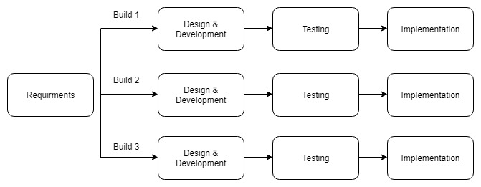

Figure 9 Iterative Model (www.tutorialspoint.com, 2019)

**Justification for choosing iterative development model**

Considering the facts mentioned below, researcher chose to follow the iterative development model to carry out the project (Kienitz, 2019),

1. **Using of new technology in the project.** When a new technology is being used in the project, the researcher will be able to learn the new technology while developing the system.
2. **Time constraint on the project.** When time constraint is problem in the project, iterative model allows to produce a working system early in the development process.
3. **Identifying requirements.** Being able to identify requirement beforehand the designing phase begins allows the researcher to focus on each iteration separately allowing to create efficient functionalities.
4. **Producing an operational product on early stage.** Being able to produce an operational product in the end of each iteration would allow the researcher to get feedbacks from users in early stages of development which helps in tweaking the system as needed.
5. **Testing and evaluating in the end of each iteration.** Being able to test and evaluate the functionalities in the end of each iteration allows the researcher to make the necessary changes in improving the system.
   1. **Planning**

To a successful project completion, a proper project plan is mandatory therefore having a proper understanding of the research topic is necessary in making the project plan. Understating the project goals and the objectives helps in identifying the tasks of the project easily. Difficulty level of each task and the time needed to complete each task should be taken into proper consideration when making the project plan. Project plan should be well prepared in order to meet the deadline in an accomplished state where as in all the tasks should be completed within the given time otherwise the project would be in an incomplete state. The project plan refers to any document that shows the timeline of project activities. The main document of a project plan is the Gantt chart and it alone is not considered as a project plan. Therefor the researcher has made a Gantt chart (attached in the Appendix A) with the tasks and the alloted time need for each task that involves in completing the project.

* 1. **Requirement Gathering and Analysis**

Researcher wanted to understand the background of e-learning and most importantly the user’s view on e-learning as well as the audience for the proposed system in advance to the requirement gathering process, so a market research survey was held in order to be conscious about the matter. Once it was done, researcher started working on gathering all the requirements needed to address the problem by doing a thorough literature review regarding the research areas related to the selected project. Literature review was done by referring to journal articles, research articles, and online articles to understand the state of the problem and figure out the requirements needed to address the problem. Furthermore in the literature review chapter, the steps taken by other e-learning websites in order to address the same problem and the technologies that can be used to overcome the problem were also discussed in order to ensure the feasibility of the project and also to narrow down the precise requirements needed for designing the system.

* 1. **Design**

In order to achieve the objectives of the system, the designing phase had to be done carefully so that the requirements gathered were fulfilled. The process of designing phase included UML diagrams to understand the structure of the system and assist with the system implementations. The UML diagrams were designed based on the requirements gathered by the researcher in order to produce a physical design of the system and this includes diagrams such as use case diagram, architecture diagram and entity relationship diagram for the purpose of understanding the system and how it works. The mentioned documents will be discussed in details below.

* + 1. **Use Case Diagram**

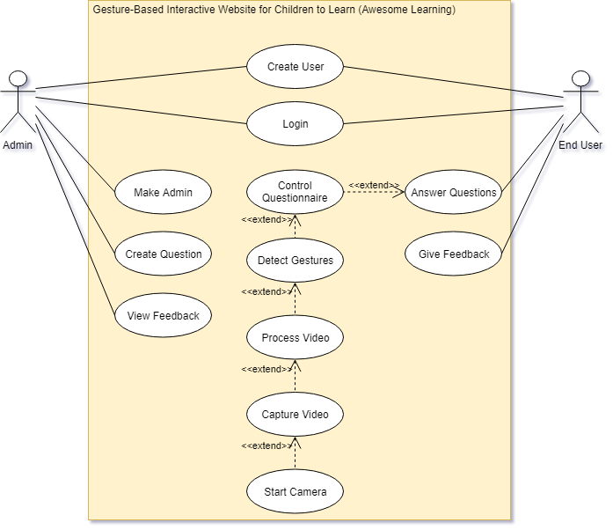

Figure 10 Use Case Diagram

Use case diagram, is a form of describing the expected behavior of a system, which is designed in a way that anyone could understand what the system is capable of. Use case diagram allows the developers to design a system from the user’s standpoint (Visual-paradigm.com, 2019). Above use case diagram represents the expected behavior of the system. This system involves two external actors in particular admin and the end user who would be interacting with the system. Admin is capable of creating users, giving users admin privileges, create questions and view feedbacks where as in the end users have limited functionalities that they can perform like create user accounts, answer questions and leave feedbacks.

* + 1. **Website Architecture**

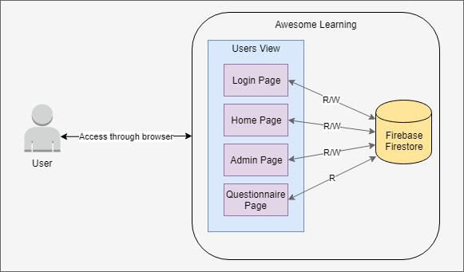

Figure 11 Website Architecture Diagram

System architecture diagrams is mainly used by the developers to understand and clarify the system structure. In the above diagram it shows that the user can access the website through the browser and according to the user privileges respective user interfaces would be shown to the user. The content on each page will be updated in real time using the stored data from the database. The database selected for the system was firebase and firestore.

* + 1. **User Interface Design**

User interface allows a user to interact with an application or a website. Since the research topic of the project is associated with improving user interaction between user and the website, designing user interfaces for the website had to be done properly. The targeted audience for the system being of children under 12 years old, developer had to design the interfaces to be simple and user friendly. Due to the lack of sense in how children learn, think and interact, the developer had to refer some e-learning sites for children in order to design the website.

* + - 1. **Home Page**

When the end user is presented with the home page, the website will prompt the user to grant access to the web camera, and then they will be asked to login or signup if they don’t have an account in order to use the other features of the page. User sign up method was made in a very simple way where the user can sign up just with an email and setting a password is kept optional for the reason that, majority of the users being children. Once the user is logged in they’ll be able to start the questionnaire by selecting the grade, subject and the number of questions to be answered using a form. This form also includes an option to select the dominant hand of the user, so that the gestures that will be used to control the questionnaire can be performed using their dominant hand.

* + - 1. **Questionnaire Page**

Questionnaire page is where all the action happens. This page was designed to be simple because complex pages can make them uncomfortable to use. According to the user selections made in the home page before starting the questionnaire, the content of the page such as instructions on how to control the questionnaire and answer the questionnaire will be changed according to the user selected dominant hand. A live camera feed out of the web camera is shown to the user so that they can see and adjust themselves while performing the gestures.

* 1. **Implementation**

# Bibliography

Ferriman, J. (2019). 10 Benefits of Using ELearning - LearnDash. [online] LearnDash. Available at: https://www.learndash.com/10-benefits-of-using-elearning/ [Accessed 11 Sep. 2019].

Reuters.com. (2019). Global E-Learning Market 2019, By Technology, Type, Learning Mode, Application, Key Vendor, End User, Emerging Trends and Growth Opportunities till 2026 - Reuters. [online] Available at: https://www.reuters.com/brandfeatures/venture-capital/article?id=72033 [Accessed 11 Sep. 2019].

Coursera. (2019). Coursera | Online Courses & Credentials by Top Educators. Join for Free. [online] Available at: https://www.coursera.org/ [Accessed 12 Sep. 2019].

Medium. (2019). Udemy VS Coursera VS Lynda — the ultimate comparison. [online] Available at: https://medium.com/@adiyagil/udemy-vs-coursera-vs-lynda-the-ultimate-comparison-70586665dca5 [Accessed 12 Sep. 2019].

Ml5js.org. (2019). ml5js·Friendly Machine Learning For The Web. [online] Available at: https://ml5js.org/ [Accessed 12 Sep. 2019].

Medium. (2019). ml5: Friendly Open Source Machine Learning Library for the Web. [online] Available at: https://medium.com/ml5js/ml5-friendly-open-source-machine-learning-library-for-the-web-e802b5da3b2 [Accessed 12 Sep. 2019].

Kienitz, P. (2019). The pros and cons of Iterative Software Development | DCSL Software Ltd. [online] DCSL Software Ltd. Available at: https://www.dcslsoftware.com/pros-cons-iterative-software-development/ [Accessed 13 Sep. 2019].

Docs.google.com. (2019). Google Forms – create and analyse surveys, for free.. [online] Available at: https://docs.google.com/forms/u/0/ [Accessed 13 Sep. 2019].

Explorable.com. (2019). Advantages and Disadvantages of Surveys. [online] Available at: https://explorable.com/advantages-and-disadvantages-of-surveys [Accessed 14 Sep. 2019].

Theclassroom.com. (2019). [online] Available at: https://www.theclassroom.com/advantages-disadvantages-of-qualitative-quantitative-research-12082716.html [Accessed 15 Sep. 2019].

Visual-paradigm.com. (2019). What is Use Case Diagram?. [online] Available at: https://www.visual-paradigm.com/guide/uml-unified-modeling-language/what-is-use-case-diagram/ [Accessed 16 Sep. 2019].